Lab 4: Informed Search: Heuristics & A*

Course:
Artificial Intelligence Lab

Submitted by:
Aman Khawar

Roll Number:
SU-92-BSSEM-S25-019

Section:
BSSE-4A

Submitted to:
Rasikh Ali

1. Objective:
The objective of this lab was to understand A* search, calculate g(n), h(n) and f(n), and compare A* with Uniform Cost Search (UCS).
2. Problem and Graph:
I used a campus navigation graph. S is the starting point and G is the goal. Edge weights represent travel time.
A* uses the formula:
f(n) = g(n) + h(n)
3. Task 1:
Manual A* Trace & Graph:

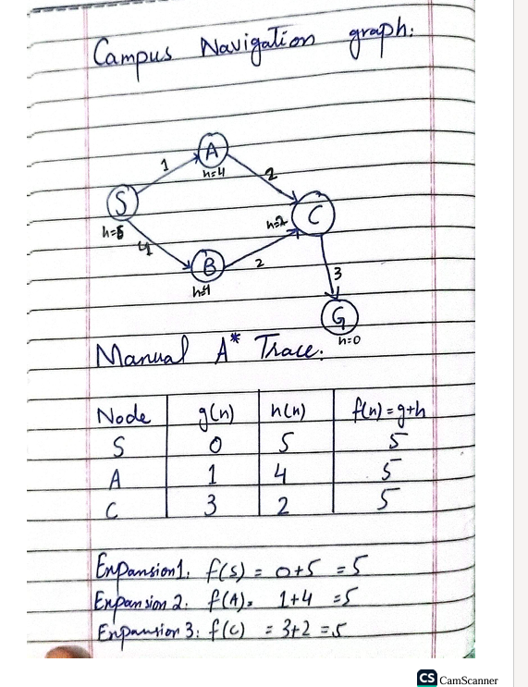

Task 2:
A* and UCS Comparison:
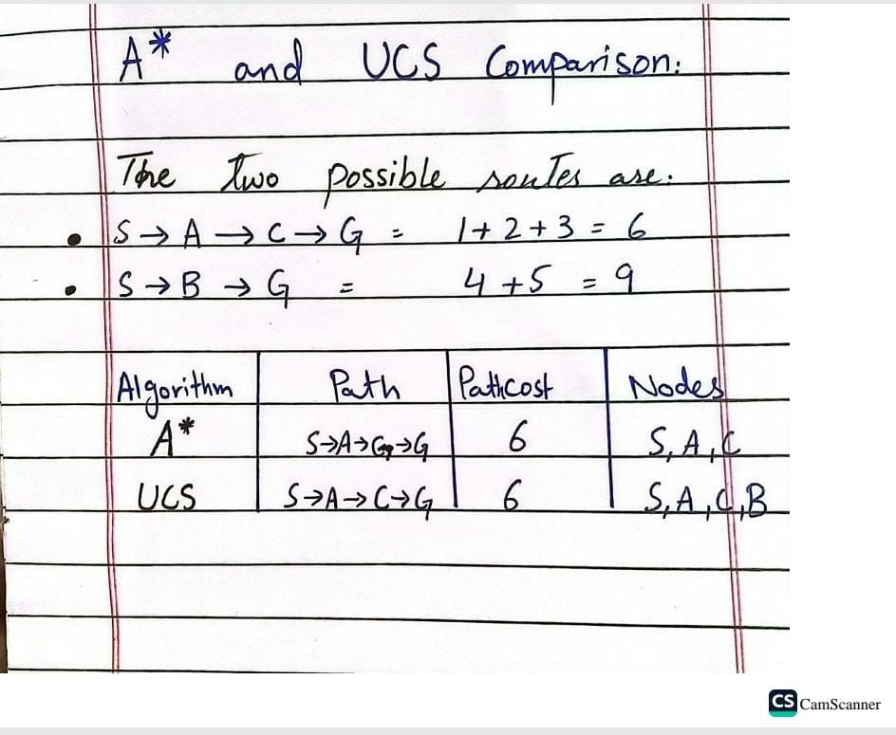
Task 3:
Overestimate Experiment:
I changed the heuristic value of C from 2 to 10. The actual remaining cost from C is 3, so 10 is an overestimate.
Because of this, A* may choose the route S -> B -> G, which costs 9, instead of the cheaper route through C, which costs 6. This shows that a wrong heuristic value can affect the result. I checked this by changing only h(C).
Edge Case and Limitation:
A* may not find the cheapest path if the heuristic value is too high. To avoid this problem, we should use a heuristic that does not overestimate the actual remaining cost.
Reflection:
I learned how A* finds a path using actual cost and estimated cost. I also learned that UCS uses zero heuristic values. These algorithms can help find routes between campus buildings. Next time, I will test different heuristic values and check the results carefully.

